# CYC Open T shirt Order Info

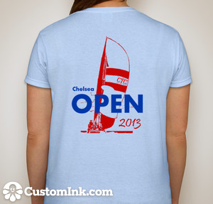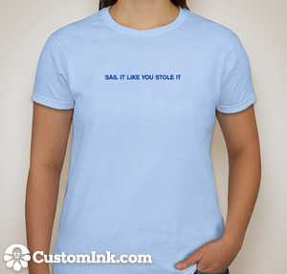

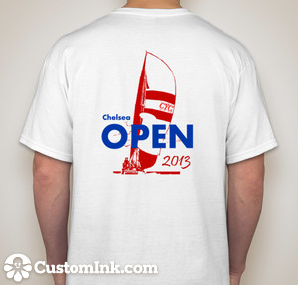

Order by email to [michaelaiellosr@aol.com](mailto:michaelaiellosr@aol.com) **NOT LATER THAN MAY 15**

Be sure to include the following:

**Mens/Ladies :** Lady’s T is a women’s cut

**Color:** Men white only, Ladies white or pink (not blue as shown)

**Size:** XS, S, M, L, XL-3XL

**How Many?**

**Your telephone number:**

**Your Name:**

**LIMITED INVENTORY AVAILABLE ON RACE DATE, DON’T DEPEND ON PURCHASING THEN**